Intro Engine Tutorial
Written by @-KiwiFX-,

Introduction
I created this engine when I knew I wanted to make my Kiwi account. I wanted to make an engine that I could use instead of Ashibara’s. It has gone through a lot of changes, and is still going through many. My end goal is to have this engine be entirely independent of outside credits and be very easy to use.

General
Before continuing, I recommend you have a very basic knowledge of pen. If not, that’s okay, but this tutorial might be harder to grasp the first time. I also recommend you have a good knowledge of coding in scratch.

Basics
To start off, I would like to talk about the alt custom block. This block functions as a variable set or change, but with the alt list instead. Take these examples:


This would set item 1 of the alt list to 1.


This would change item 1 of the alt list by 1.

It might be confusing at first, but just remember: the alt blocks function the same as variable set and change blocks.

Easing
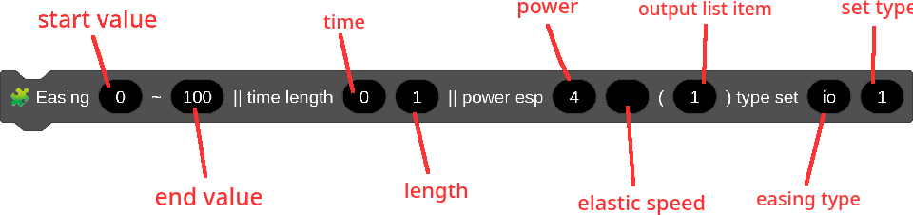
Easing is one of the most important parts of making intros. It goes from one number to a second number smoothly based on the timer. (Just a note, when using this easing yourself, feel free to change the names of inputs if you find it confusing.)

The time input is the timer value the easing will start at. (i.e., If the timer is 3 and the time value is 3, the easing will start then).

The length input is how long the easing will last.

The power input determines how linear the easing will be. The closer it is to 1, the less smoothing it will have. Though, larger numbers will cause it to look faster. The key is to use the power input just right based on whether the easing needs to be smooth, fast, or linear.

The esp input, or elastic speed, is used to determine how much elastic you want when using elastic easing.

The output input, is used to set an alt list item to the easing value derived from the easing block, because you need a way to use what easing you just calculated! The number in this input is the alt list item you want it to output to. (i.e., If you want your easing value in alt list item 1, the set this value to 1.)

The type input is used for what type of easing you want. Look at this table:

Easing type | in | out
i | smooth | quick
o | quick | smooth
io | smooth | smooth
e | quick | smooth + elastic
(Ha ha this chart is really not that easy to understand)

The set input is used for what type of list output you want. If it’s set to 1, the easing will overwrite whatever is in the list item. If it’s empty, the easing will not overwrite whatever is in the list item until it is time for the easing to start. If it’s set to +, the easing will function the same as when the set input is blank, but the start input will be set to whatever the output list item is. (This is useful for chain easing, when you need to ease from 0 to 100, but a short time later need to go from 100 to 200, but don’t want it to interfere with the previous easing and jump in values.)

Whew! That was a lot of nerdy junk about easing! When do we get to the fun stuff?

Stamping
If you want to render sprites in pen, you need to stamp it. Think of stamping like this: When you stamp something, it goes on top of anything else you’ve stamped before. With this in mind, we can control how our things show up in the intro. If you want something in the back, stamp it first. If you want something on the layer just above that, stamp it second. If you want something on the top, stamp it last.

Pen is somewhat like clones. With clones, you create the clone, and can move and size it whenever you want after you’ve created it. With pen, you have move and size to the right position, then you can stamp it. You can’t move anything after you’ve stamped it, just like bitmap versus vector. You can move vector objects around whenever, but in bitmap, you can’t.

Usage of my engine
If you want to use my engine, you need to know how it works. To start off, anything you want in the background needs to be placed in the 🖋️ BG custom block. Likewise, anything that needs to be on the foreground (top) goes in the 🖋️ FG custom block. Same goes with the Text (plain old text) and FX (short for effects) blocks. These custom blocks are just general layering. Anything more detailed needs to be done inside the custom blocks themselves. (For example, in the FX, say you want a shockwave and a line explosion to show up. You would put an SW and LE effect block in. But, if you wanted the shockwave to be behind the line explosion, you would put the SW block before the LE block.)

Example of easing
To make easing a little easier to understand, I’m including an example of text going from size 0 to size 100 in 1 second.
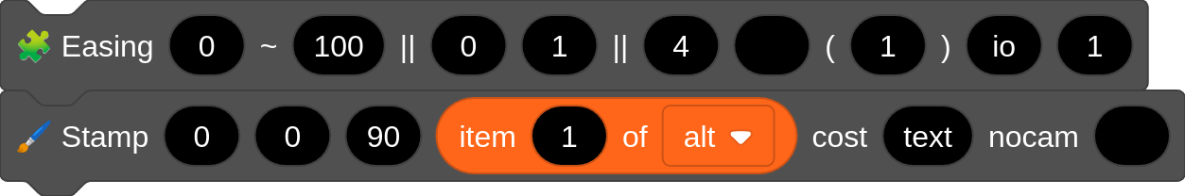

(whoops I forgot to switch to the tutorial version of my engine when taking the screenshot)

In this example, you see a bunch of random numbers that don’t seem to make sense. Trust me, they do if you know what to look for. I’ll try to make sense of this for you. In the stamp block, you see the first 4 inputs. Those are x, y, direction, and size. The cost input is short for costume. Nocam is if you want the stamped sprite to be effected by that camera. If you set nocam to 1, it will stamp without camera control. Anything else in the input will make the stamp use camera control. This nocam input is used in a few other places, and functions the same elsewhere.

You can see that the size input has item 1 of alt in it. This is because the output of the easing is set to 1. So, naturally, we would be getting our value from list item 1. The type set to io means it is smooth in, smooth out. Time 0 and length 1 means it starts at 0 and takes exactly 1 second to finish. Power 4 is a good default value to use. As you get used to easing, you’ll learn what looks right and find your own style. Try to observe the engines of ashibara and kobajin, since their engines function really similar. And while you’re at it, maybe you can make your own engine as well!

Conclusion
I hope you make test projects and ask for feedback on them. It’s crazy how hard it is to cover everything a tutorial, so please, fumble your way along and ask me many questions, it’s okay! I struggled making a tutorial on this since there is so much to cover. I haven’t even explained any sort of effects or anything. Please please please ask me detailed questions, don’t say “idk what to do! I don’t understand!” For the sake of my time, and getting this tutorial out soon, I am leaving this as is, and it can be edited on github if you have more to add. I will be editing this as more people ask questions.

Faretek I know you’re going to ramble about how bad my engine and tutorial are xD

